Canada-ASEAN Scholarships and Educational Exchanges for Development (SEED) – 2023-2024 Application Form

In each section, you will see screenshots from the SEED website for your reference. Please make sure to select and type in each answer section highlighted in yellow.
IMPORTANT: The complete application must be in Word format.

PROGRAM (SELECT ONE BY MARKING “X”):
- College/Undergraduate – four months or one academic term: ______
- Graduate – four months or one academic term: ______
- Graduate – fix or six months: ______

CONTACT PERSON RESPONSIBLE FOR THE PROGRAM AT CANDIDATE'S HOME INSTITUTION
- Salutation (Mandatory): ______
- First Name (Mandatory): ______
- Last Name (Mandatory): ______
- Job Title (Mandatory): ______
- Institution (Mandatory): ______
- Department/Office (Mandatory): ______
- Address (Mandatory): ______
- City (Mandatory): ______
- Province/State/Region: ______
- Postal Code/ZIP: ______
- Country (Mandatory): ______
- Email (Mandatory): ______

CANDIDATE INFORMATION
- Salutation (Mandatory): ______
- First Name as shown on passport (Mandatory): ______
- Last Name as shown on passport (Mandatory): ______
- Gender (Mandatory): ______
- Email (Mandatory): ______
- Country of Citizenship (Mandatory): ______
- Degree Sought at Home Institution (Mandatory): ______
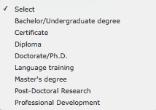
- Field of Study (Mandatory): ______
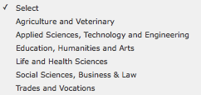
- Discipline (Mandatory): ______
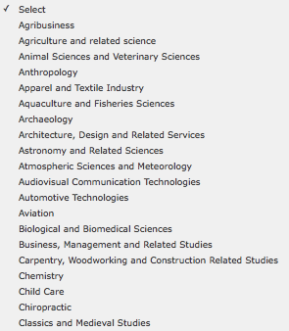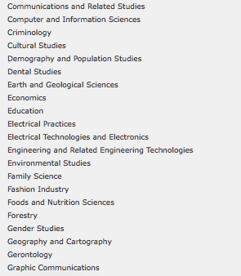
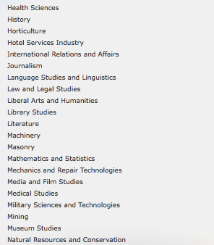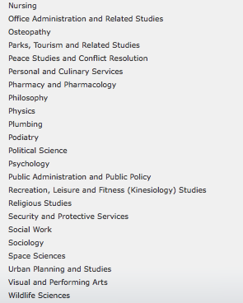
- Expected Completion Date of Degree (mm/yyyy) (Mandatory): ______

FOR RESEARCH (UNDERGRADUATE / GRADUATE) APPLICANTS ONLY:
*Please note: Research students may NOT take classes, as they are expected to work full-time (40 hours per week) on their research projects. This option is best for graduate students who are working on their thesis or dissertation research, and whose home supervisor is already collaborating with a Lakehead professor. Please discuss with your home supervisor before contacting a potential supervisor at Lakehead. You are responsible for proposing your own research project and finding your own supervisor at Lakehead. For assistance with research applications, please contact Jill Sherman at intl.research@lakeheadu.ca. If you would like to do a combination of classes and research (e.g. independent study), please apply as a STUDY student.

CANADIAN ACADEMIC SUPERVISOR
- Salutation (Mandatory): ______
- First Name (Mandatory): ______
- Last Name (Mandatory): ______
- Job Title (Mandatory): ______
- Department/Office (Mandatory): ______
- Phone: ______
- Fax: ______
- Email (Mandatory): ______
- Supervisor’s Campus (Mark “X” to Select)”
Thunder Bay ___
Orillia ___
Barrie (Lakehead-Georgian) ___
INTENDED RESEARCH
- Research Project Title (if applicable): ______
- Provide a summary of the research project. (Mandatory) :
______
(MAXIMUM OF 1000 CHARACTERS)

- Expected Start Date of Scholarship (dd/mm/yyyy) (Mandatory): ______
- Expected End Date of Scholarship (dd/mm/yyyy) (Mandatory): ______

FOR ACADEMIC STUDY/UNDERGRADUATE STUDENTS ONLY:
- Provide a list of 3-4 undergraduate level Lakehead courses to be undertaken (maximum of 1000 characters). Please reference the Academic Calendar for the course codes and names. Please note that these courses can be changed. Students are not eligible to take courses in the following departments: Nursing, Social Work, Education, Law and Medicine. (Mandatory): ___________________________________________________________________________________
- Language of Study at Canadian Host Institution (Mandatory): ______
- Expected Start Term of Scholarship at Lakehead University (Mark “X”:
Fall 2023: ______
Winter 2024: ______
*Fall Semester (September 1, 2023 – December 31, 2023) and Winter Semester (January 1, 2024 – April 30, 2024).

Supporting Documents

All of the following documents must be in English and submitted to us in one of the following formats: .pdf, .jpg, .doc, .docx, .txt or .gif. Each document must be smaller than 5 MB in order for the application to upload successfully. Please save and upload each document separately!

· Completed SEED 2023/2024 Application Form

· Proof of citizenship: A copy of the candidate's passport (highly recommended for submission) or national identity card with valid dates and photo. Note: a driver’s licence, permanent residence card, work permit, student card, health card, birth certificate or baptism certificate are not accepted as proof of citizenship. Candidates from countries/territories that do not issue national identity cards must provide copies of their valid passports. The country/territory of citizenship selected in the online application form must be the same as the country/territory of the proof of citizenship.

· Proof of full-time enrolment: A letter in English or French from the home institution, on official letterhead, dated within the last six months, confirming that the candidate is currently enrolled in a full-time program (maximum one page). Note: copies of transcripts, a student card or a letter of admission are not acceptable. The letter must clearly state:
1. The type of program and the level of study of the candidate at the home institution;
2. The full-time enrolment status at the home institution; and
3. The anticipated completion date of the degree at the home institution.

· Letter of intent from the candidate: (maximum one page - see criteria below).
- Explains the nature of studies or research to be undertaken
- Provides rationale for study in Canada and for the choice of institution, program and supervisor and how the proposed program of study or research will relate to their future career
- Explains how undertaking study or research in Canada will empower the student to apply their learning to address the 2030 Agenda for Sustainable Development
- Explains how they intend to use their learning to help combat poverty and narrow the development gap in the ASEAN region in their future career
- Identifies the Sustainable Development Goal (SDG) their proposed study or research in Canada is aligned with and will contribute to
- Candidates from Cambodia, Indonesia, Laos, Malaysia, Myanmar, the Philippines, Thailand or Vietnam must provide an explanation of how their learning in Canada will help to combat poverty in their home country
- Candidates from Brunei or Singapore must provide an explanation of how their learning in Canada will help combat poverty in one of the other eight ASEAN countries
· Letter of support from the home institution: A letter dated within the last six months from the candidate's instructor, professor or international director on the institution's official letterhead explaining the nature of study or research to be undertaken in Canada and how the candidate and the home institution will benefit from this scholarship program (maximum one page).
Key factors for a successful support letter:
1. Personalized letters will increase the candidate’s chances to receive the scholarships (Move away from a template).
2. How would the SEED scholarship impact the candidate's future study and goals?
3. What are the benefits to your institution by sending the students to Canada?
Research (Undergraduate and Graduate) Applications ONLY
· Letter of invitation from the Canadian supervisor: Applications for graduate or research-based students must include a letter from the Canadian supervisor indicating their willingness to support and mentor the candidate. This letter must be on institutional letterhead, be in English or in French, and be signed. It must describe the nature and scope of the research collaboration with the student’s home institution, the support they will receive during the exchange period and how the Canadian institution, supervisor and peers will benefit from the exchange (maximum one page).

Academic Study (Undergraduate) Applications ONLY
· A list of 3-4 Lakehead University courses the applicant is interested in taking: Students can reference our academic calendar from our current 2022/2023 academic year when looking for courses to take. The courses for the 2023/2024 academic year will not be available until approximately June 2023. However, most courses will still be available, and it will give them an idea of what is available to them for study. HERE is the link to our academic calendar. The student will need to choose the program they are interested in (example: Business), and then it will list the courses available. Please note that these courses can be changed. Students are not eligible to take courses in the following departments: Nursing, Social Work, Education, Law and Medicine

· Student’s transcript (in English)

· Attached Privacy Notice Statement: a copy of the Privacy Notice Statement for non-Canadian participants signed by the candidate and dated within the last six months. (this document is also attached to this email).

