**Canada-ASEAN Scholarships and Educational Exchanges for Development (SEED) – FALL Semester / 2025-2026 Application Form for Student**

|  |
| --- |
| In each section, you will see screenshots from [the SEED website](https://www.educanada.ca/scholarships-bourses/can/institutions/asean-anase.aspx?lang=eng) for your reference. Please make sure to select and type in each answer section highlighted in yellow. **IMPORTANT: The complete application must be in Word format.**  **FOR RESEARCH (UNDERGRADUATE / GRADUATE) APPLICANTS ONLY:**  *Please note: Research students may NOT take classes, as they are expected to work full-time (35 hours per week) on their research projects. **This option is best suited for Graduate students** who are working on their thesis dissertation research, and whose home supervisor is already collaborating with a Lakehead professor.  Undergraduate students may apply for a research stay if there is an existing, genuine research collaboration already existing.  Students are encouraged to discuss with their home supervisor(s) before contacting a potential supervisor at Lakehead. Students are responsible for proposing their own research project and finding their own supervisor at Lakehead. For assistance with research applications, please contact Jill Sherman at [intl.research@lakeheadu.ca](mailto:intl.research@lakeheadu.ca). If you would like to do a combination of classes and research (e.g. independent study), please apply as a STUDY student. |

1. **CANDIDATE INFORMATION**

* Prefix/Salutation (Mandatory): ______

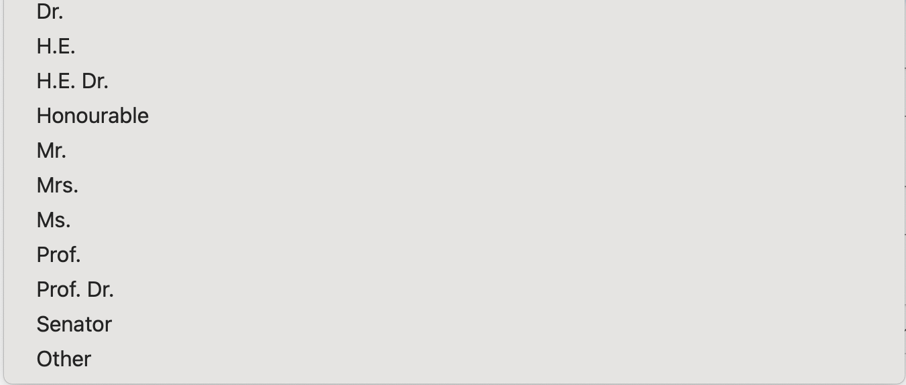

* First Name **as shown on passport** (Mandatory): ______
* Last Name **as shown on passport** (Mandatory): ______
* Gender (Mandatory): ______

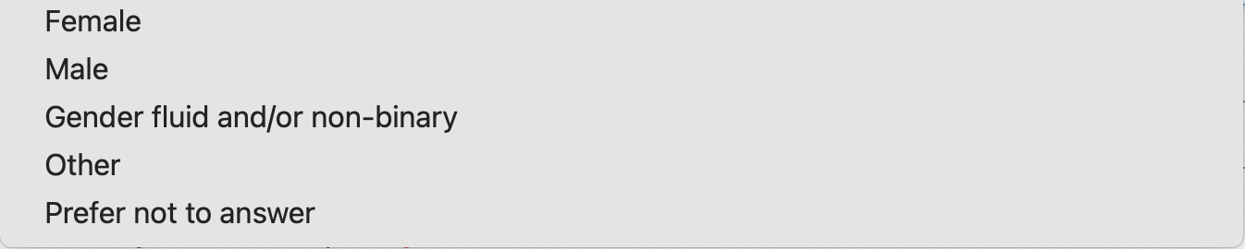

* If “Other” is selected as the candidate’s gender, please indicate the candidate’s gender here: ______

* Email (Mandatory): ______
* Country of Citizenship (Mandatory): ______

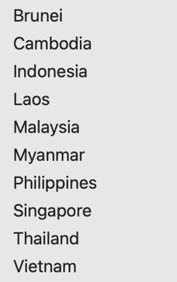

* Degree Sought at Home Institution (Mandatory): ______  
  
* Field of Study (Mandatory): ______

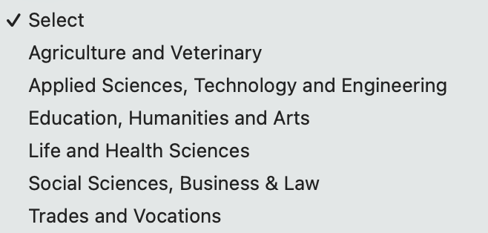

* Discipline**(**Mandatory):______

* Expected Completion Date of Degree (mm/yyyy) (Mandatory): ______
* To be eligible, you must be:
  + A student enrolled full-time at post-secondary institution in an eligible country/ territory
  + Paying tuition fees to that institution at the time of application and for the full duration of your exchange

1. **INTENDED SCHOLARSHIP PROGRAM INFORMATION**

* Select the scholarship component **(Must select only ONE option with “X”)** (Mandatory):
  + Undergraduate - 4 months or 1 academic term: ______
  + Graduate - 4 months or 1 academic term: ______
* Expected start date of scholarship (in the format of dd/mm/yyyy) (Mandatory): ______
  + *\*The candidate must select a date between* ***August 1, 2025 and October 1, 2025*** *in the format of dd/mm/yyyy*
* Expected end date of scholarship (in the format of dd/mm/yyyy) (Mandatory): ______
  + *\*Fall Semester (September 2, 2025 – December 18, 2025)*
* Select the type of exchange activity **(Must select only ONE option with “X”)** (Mandatory):
  + Research ______
  + Study ______
* In the text box below, provide a summary of the research project or courses to be undertaken (Maximum 1,000 characters) (Mandatory for both study and research candidates):
* **NOTE FOR RESEARCH ONLY:**
  + Provide a Research Project Title (only if applicable): ______
* **NOTE FOR ACADEMIC/STUDY ONLY:**
  + Provide a list of 3-5 undergraduate level Lakehead courses to be undertaken
  + Please reference the [**Academic Timetable**](https://www.lakeheadu.ca/timetable) for the [course codes and names.](https://csdc.lakeheadu.ca/Catalog/ViewCatalog.aspx?pageid=viewcatalog&catalogid=30&chapterid=10308&loaduseredits=False)   
    *NOTE - Students are not eligible to take courses in the following departments: Nursing, Social Work, Education, Law and Medicine*

|  |
| --- |
| [INSERT SUMMARY OR COURSE LIST HERE]  **(MAXIMUM OF 1000 CHARACTERS):** Please ensure not to go over the 1000 characters. |

1. **CANDIDATE HOME INSTITUTION INFORMATION**

* Institution Name in English (Mandatory): ______ (No short form or abbreviation will be accepted)
* Address (Mandatory): ______
* City/Town (Mandatory): ______
* Province/Territory/Region: ______
* Postal code/ZIP code: ______
* Country (Mandatory): ______

1. **CONTACT PERSON RESPONSIBLE FOR THE SEED SCHOLARSHIP AT CANDIDATE'S HOME INSTITUTION**

* Prefix/Salutation (Mandatory): ______



* First Name (Mandatory): ______
* Last Name (Mandatory): ______
* Job Title (Mandatory): ______
* Department/Office (Mandatory): ______
* Phone (Mandatory): ______
* Email (Mandatory): ______

1. **CANADIAN ACADEMIC SUPERVISOR**

* Salutation (Mandatory): ______
* First Name (Mandatory): ______
* Last Name (Mandatory): ______
* Job Title (Mandatory): ______
* Department/Office (Mandatory): ______
* Phone (Mandatory):  ______
* Email (Mandatory): ______
* Supervisor’s Campus (Mark “X” to Select)”  
  Thunder Bay ___  
  Orillia ___

**Please see the next page for an explanation of the SEED Supporting Documents - For Students**

**SEED Supporting Documents – For Students**

**All of the following documents must be in English.** Each document must be smaller than 5 MB in order for the coordinator to upload your application and supporting document successfully.

* **Completed SEED 2025/2026 Application Form in Word format only**
* **Proof of citizenship:**
  + a copy of the candidate's passport (highly recommended for submission) or national identity card with a photo and valid dates
* documents not accepted as proof of citizenship are: driver’s license, permanent residence card, work permit, student card, health card, birth certificate or baptismal certificate
* proof of citizenship selected must be from the same country/territory as the citizenship selected in the online application form
* **Letter of proof of full-time enrolment from the home institution**
* on official letterhead
* dated within the last six months
* confirming that the candidate is currently enrolled in a full-time program
* The type of program and the level of study of the candidate at the home institution;
* The full-time enrolment status at the home institution; and
* The anticipated completion date of the degree at the home institution.
* *Note****:*** *copies of transcripts, a student card or a letter of admission are not acceptable.*
* *Note: the letter of enrolment MUST say the words “full-time” in the document*
* **Letter of intent from the candidate (maximum one page)**
* Explains the nature of studies or research to be undertaken
* Provides rationale for study in Canada and for the choice of institution, program and supervisor and how the proposed program of study or research will relate to their future career
* Explains how undertaking study or research in Canada will empower the student to apply their learning to address the 2030 Agenda for Sustainable Development
* Explains how they intend to use their learning to help combat poverty and narrow the development gap in the ASEAN region in their future career
* Identifies the Sustainable Development Goal (SDG) their proposed study or research in Canada is aligned with and will contribute to
* Candidates from Cambodia, Indonesia, Laos, Malaysia, Myanmar, the Philippines, Thailand or Vietnam must provide an explanation of how their learning in Canada will help to combat poverty in their home country
* Candidates from Brunei or Singapore must provide an explanation of how their learning in Canada will help combat poverty in one of the other eight ASEAN countries

* **Letter of support from the home institution** (**maximum one page**)
  + on official letterhead
  + dated within the last six months
  + from the candidate's instructor, professor or international director
  + explains the nature of study or research to be undertaken in Canada and how the candidate and the home institution will benefit from this scholarship program  
    **Key factors for a successful support letter:**

1. Personalized letters will increase the candidate’s chances to receive the scholarships (Move away from a template).
2. Explain how the SEED scholarship impacts the candidate's future study and goals?
3. Explain what the benefits are to your institution by sending the students to Canada?

* **Letter of invitation from the Canadian supervisor (maximum one page: ALL research applications**)
  + on official letterhead
  + dated within the last six months
  + signed by the Canadian supervisor
  + describes the nature and scope of the research collaboration with the student’s home institution
  + confirms their willingness to support and mentor the candidate during the exchange period
  + explains how the Canadian institution, supervisor and peers will benefit from the exchange
* **Academic Study (Undergraduate) Applications ONLY**
* **A list of 3-5 Lakehead University courses the applicant is interested in taking:** Students can reference our academic calendar from our current 2024/2025 academic year when looking for courses to take.  The courses for the 2025/2026 academic year will not be available until approximately June 2025. However, most courses will still be available, and it will give them an idea of what is available to them for study. [HERE is the link](https://www.lakeheadu.ca/timetable) to our academic timetable. The student will need to choose the program they are interested in (example: Business), and then it will list the courses available.  Please note that these courses can be changed.  *NOTE - Students are not eligible to take courses in the following departments: Nursing, Social Work, Education, Law and Medicine*
* **Student’s transcript** (in English)
* **Attached Privacy Notice Statement**: a copy of the[Privacy Notice Statement for non-Canadian participants](https://www.educanada.ca/scholarships-bourses/assets/pdfs/privacy-notice-statement-non-canadians-eng.pdf) signed by the candidate and dated within the last six months (this document is also attached to this email)