Scholarships and Educational Exchanges for Development – Phase 2 (SEED-2) application form – 2026-2027 Application Form for Student

In each section, you will see screenshots from the SEED website for your reference. Please make sure to select and type in each answer section highlighted in yellow.
IMPORTANT: The complete application must be in Word (.docx) format.
To be eligible, candidates must be:
✔ citizens of a country listed below:
- ASEAN Member States: Brunei Darussalam, Cambodia, Indonesia, Laos (Lao People’s Democratic Republic (Lao PDR)), Malaysia, Myanmar, The Philippines, Singapore, Thailand, Timor-Leste, Vietnam;
- Pacific Island Countries: Cook Islands, Fiji, Kiribati, Marshall Islands, Micronesia, Nauru, Niue, Palau, Papua New Guinea, Samoa, Solomon Islands, Tonga, Tuvalu, Vanuatu;
- Mongolia.
✔ enrolled full-time at a post-secondary institution in an eligible country
✔ paying tuition fees to that institution at the time of application and for the full duration of their exchange

- CANDIDATE INFORMATION
- Prefix/Salutation (Mandatory): ______
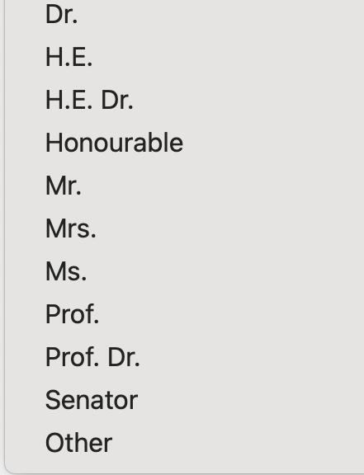
- First Name as shown on passport (Mandatory): ______
- Last Name as shown on passport (Mandatory): ______
- Gender (Mandatory): ______
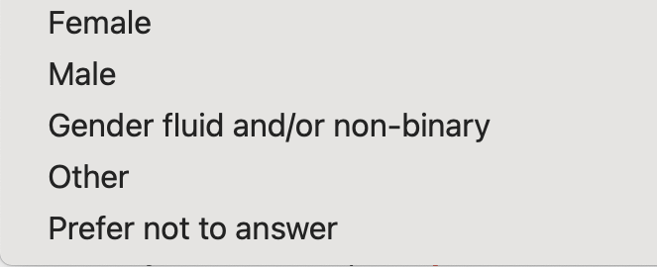
- Email (Mandatory): ______
- Country of citizenship (Mandatory): ______
- Degree sought at the home institution (Mandatory): ______
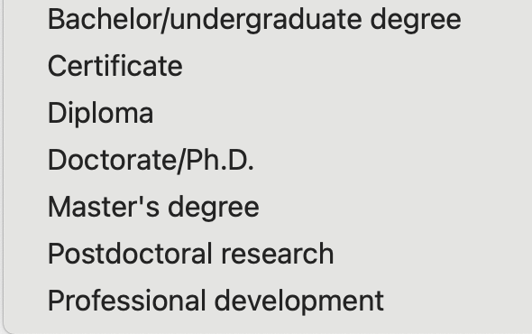
- Field of Study (Mandatory): ______
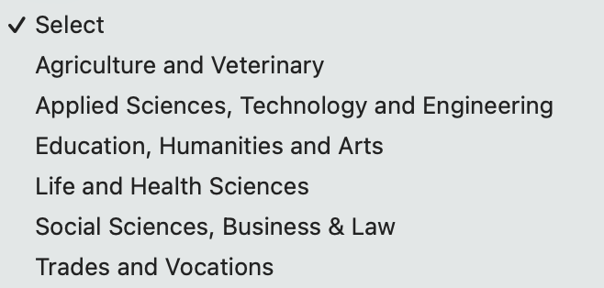

- Discipline (Mandatory) Select from the options below: ______
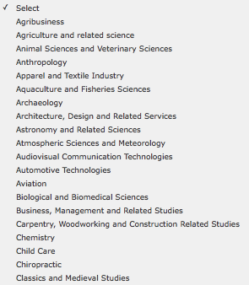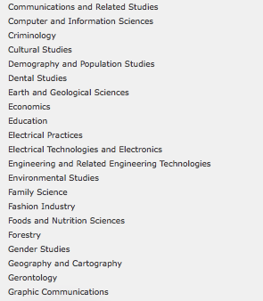
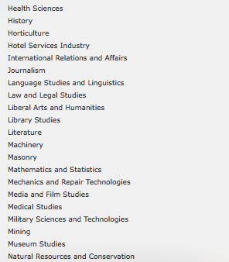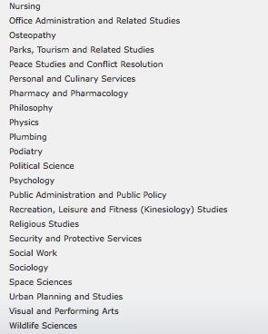
- Expected Completion Date of Degree (mm/yyyy) (Mandatory): ______

INFORMATION FOR RESEARCH APPLICANTS ONLY:
*Please note: Research students may NOT take classes, as they are expected to work full-time (35 hours per week) on their research projects. This option is best suited for Graduate students who are working on their thesis dissertation research, and whose home supervisor is already collaborating with a Lakehead professor. Undergraduate students may apply for a research stay if there is a genuine research collaboration already existing. If you would like to do a combination of classes and research (e.g. independent study), please apply as a STUDY student.

Students are encouraged to discuss with their home supervisor(s) before contacting a potential supervisor at Lakehead. Students are responsible for proposing their own research project and finding their own supervisor at Lakehead. Both graduate and undergraduate research applicants are required to provide a Letter of Invitation from a Lakehead supervisor.

For assistance with research applications, please contact Jill Sherman at intl.research@lakeheadu.ca.
- INTENDED SCHOLARSHIP INFORMATION
- Select the scholarship component (Must select only ONE option with “X”) (Mandatory):
  - College/Undergraduate - 4 months or 1 academic term: ______
  - College/Undergraduate - 8 months or 2 academic terms: ______
  - Graduate (RESEARCH ONLY) - 4 months or 1 academic term: ______
  - Graduate (RESEARCH ONLY) - 5 to 6 months: ______
- Expected scholarship start date between August 1, 2026 and February 1, 2027 (in the format of dd/mm/yyyy) (Mandatory): ______
- Expected end date of the scholarship (in the format of dd/mm/yyyy) (Mandatory): ______
- Select the type of exchange activity the candidate will undertake at the Canadian institution (Must select only ONE option with “X”) (Mandatory):
  - Research ______
  - Study ______
- In the text box below, provide a summary of the research project or courses to be undertaken (Maximum 1,000 characters) (Mandatory for both study and research candidates):
  - NOTE FOR RESEARCH ONLY:
    - Provide a Research Project Title (only if applicable): ______
  - NOTE FOR ACADEMIC/STUDY ONLY:
    - Provide a list of 3-5 undergraduate level Lakehead courses to be undertaken
    - Students can reference our timetable from our current 2025/2026 academic year when looking for courses to take. The timetable for the 2026/2027 academic year will not be available until approximately June 2026. However, most courses will be available again, so the current timetable will give an idea of what may be available for study. The student will need to choose the program they are interested in (example: Business), and then it will list the courses available. Please note that these courses can be changed during the future course registration process. Please reference the Academic Timetable for the course codes and names.
NOTE - Students are not eligible to take courses in the following departments: Nursing, Social Work, Education, Law and Medicine.
[INSERT SUMMARY OF THE RESEARCH PROJECT OR COURSES TO BE UNDERTAKEN HERE]

(MAXIMUM OF 1000 CHARACTERS): Please ensure not to go over the 1000 characters.
- Language of study at the Canadian institution: English

- CANDIDATE HOME POSTSECONDARY INSTITUTION INFORMATION
- Institution Name in English (Mandatory): ______ (No short form or abbreviation will be accepted)
- Address (Mandatory): ______
- City/Town (Mandatory): ______
- Province/Territory/State (Mandatory): ______
- Postal code/ZIP code (Mandatory): ______
- Country (Mandatory): ______

- CONTACT PERSON RESPONSIBLE FOR THE SCHOLARSHIPS AND EDUCATIONAL EXCHANGES FOR DEVELOPMENT - PHASE 2 (SEED-2) AT THE CANDIDATE’S HOME INSTITUTION
- Prefix/Salutation (Mandatory): ______
- First Name (Mandatory): ______
- Last Name (Mandatory): ______
- Job Title (Mandatory): ______
- Department/Office (Mandatory): ______
- Phone (Mandatory): ______
- Email (Mandatory): ______
- Preferred language of correspondence: English

- CANADIAN ACADEMIC SUPERVISOR INFORMATION (required for Research candidates)
- Salutation: ______
- First Name: ______
- Last Name: ______
- Job Title: ______
- Department/Office: ______
- Phone: ______
- Email: ______
- Preferred language of correspondence: English
- Supervisor’s Campus (Mark “X” to Select)”
Thunder Bay ___
Orillia ___

Please see the next page for an explanation of the SEED Supporting Documents - For Students
SEED Supporting Documents – For Students

All of the following documents must be in English. Each document must be smaller than 5 MB in order for the coordinator to upload your application and supporting document successfully.

- Completed SEED 2026/2027 Application Form in Word format only

- Proof of citizenship:
  - a copy of the candidate's passport (highly recommended for submission) or national identity card with a photo and valid dates
- documents not accepted as proof of citizenship are: driver’s license, permanent residence card, work permit, student card, health card, birth certificate or baptismal certificate
- proof of citizenship selected must be from the same country/territory as the citizenship selected in the application form above.

- Letter of proof of full-time enrolment from the home institution
  - on official letterhead
  - dated within the last six months
  - confirms that the candidate is currently enrolled in a full-time program (letters that do not confirm full-time student status will be deemed incomplete and not eligible)
  - Note: copies of transcripts, a student card or a letter of admission are not acceptable.

- Letter of intent from the candidate (maximum one page)
- Explains the nature of studies or research to be undertaken
- Provides rationale for study in Canada and for the choice of institution, program and supervisor and how the proposed program of study or research will relate to their future career
- Explains how undertaking study or research in Canada will empower the student to apply their learning to address the 2030 Agenda for Sustainable Development
- Explains how they intend to use their learning to help reduce poverty and narrow the development gap in their region in their future career
- Identifies the Sustainable Development Goal (SDG) their proposed study or research in Canada is aligned with and will contribute to (letters that do not identify an SDG will be deemed incomplete and not eligible)
- Candidates from Cambodia, Indonesia, Laos, Malaysia, Myanmar, the Philippines, Thailand, Timor-Leste or Vietnam must provide an explanation of how their learning in Canada will help to reduce poverty in their home country
- Candidates from Brunei or Singapore must provide an explanation of how their learning in Canada will help to reduce poverty in one of the other nine ASEAN countries
- Candidates from Fiji, Kiribati, Marshall Islands, Micronesia, Nauru, Niue, Palau, Papua New Guinea, Samoa, Solomon Islands, Tonga, Tuvalu or Vanuatu must provide an explanation of how their learning in Canada will help to reduce poverty in their home country
- Candidates from the Cook Islands must provide an explanation of how their learning in Canada will help to reduce poverty in one of the other thirteen eligible Pacific Island Countries
- Candidates from Mongolia must provide an explanation how their learning in Canada will help to reduce poverty in their home country

- Letter of support from the home institution (maximum one page)
  - on official letterhead
  - dated within the last six months
  - from the candidate's instructor, professor or international director
  - explains the nature of study or research to be undertaken in Canada and how the candidate and the home institution will benefit from this scholarship program
  - Assesses the candidate’s commitment and capacity to use the program of study or research in Canada to help reduce poverty and narrow the development gap in their country or region
Key factors for a successful support letter:
- Personalized letters will increase the candidate’s chances to receive the scholarships (Move away from a template).
- How would the scholarship impact the candidate's future study and goals?
- What are the benefits to your institution by sending the students to Canada?
- Letter of invitation from the Canadian supervisor (Research students only, maximum one page)
  - on institutional letterhead
  - dated within the last six months
  - signed by the Canadian supervisor
  - describes the nature and scope of the research collaboration with the student’s home institution
  - confirms their willingness to support and mentor the candidate during the exchange period
  - explains how the Canadian institution, supervisor and peers will benefit from the exchange

- Candidate’s most recent academic transcript (in English)

- Attached Privacy Notice Statement: a copy of the Privacy Notice Statement for non-Canadian participants signed by the candidate and dated within the last six months (this document is also attached to this email)

